

**Faculty of Computer Science**

**Mobile Computing (CS326x)**

**Final Project**

**Auto Identification and Data Capture (AIDC) – also Mobile & Wireless RFID**

**Supervised By**: **TA. Fatma Kilany**

**Contributors:**

**Ahmed Emam 205137 ZiadMostafa 201455 Omar Tarek 205165**

**Introduction:**

Nowadays, people get attracted to things that can be done easily and quickly. Therefore, humanity has been evolving recently focusing on inventing new technologies to facilitate this issue. Internet of Things is one of the best technologies for Auto Identification and Data Capture or in short AIDC. Moreover, in AIDC the process will mostly be done by the computer except for the code scanning part. Therefore, the process takes bunch of seconds overall some by the computer and some for the scanning. Some examples include: Magnetic stipes, Barcodes, Smart cards, and Optical Character Recognition (OCR), QR Code etc.. Basically, something will be analyzed leading to an output just like in OCR, where text will be scanned character-by-character producing character image and a machine-readable character code will be the result of translation.

**Background:**

AIDC analyzation is usually implemented on videos , sounds or images. Furthermore, Transducer is a device that can be so helpful when having digital files changed from data. Data decoding, Data encoding , and Machine scanning are the three major processes Automatic Identification and Data Capture often rely on , but

should be done in this order: Data encoding -> Machine scanning -> Data Encoding.

Data encoding: process by which you get a specified format to secure the data you are transmitting by converting a sequence of character, alphabets or a data. Then, Machine Scanner which role is conversion from electrical signal to analog signal.

Finally, Data encoding and its role is conversion of signal to the original data form. QR code is a 2D code with various versions and to be more specific 7 and is one of the technologies mostly used nowadays, since it’s able to facilitate our daily life stuff e.g: attendance in school or jobs which can be done by simply scanning an image. Recently, QR code evolved a lot that it can be scanned using Mobile Phones cameras making it so much easier for employees and faster too. What QR code looks like:



How it works:

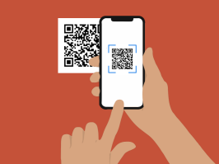

There are many applications that use QR codes and many companies too for how outstanding it makes so many things faster.

One of the companies that adopted the QR code in their business was British Airways making the check-ins so much easier.

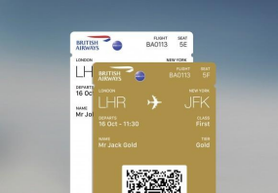

Providing a perfect example for how QR codes can be used in all sorts of things

and still being efficient in so many ways as the passengers will scan the codes for faster check-ins and avoiding waiting for so long in queues.

Nowadays, people are attempting to rely on **biometrics identification**, which is a method of human recognition using physical traits such as fingerprint, iris, Face ID, and signatures. Because this technology is thought to provide high security, it is generally used by federals, governments, and the military. It can also take place on mobile phones in ways such as Fingerprint authentication and Apple Face ID authentication.

Furthermore, Radio Frequency Identification (RFID) is a wireless system made of two critical components 1-tags 2-radars, and it’s one of the most powerful AIDC technologies since it has several uses, such as Inventory control, Equipment tracking, Personnel tracking, etc.. RFID is based to deal with waves,but specifically the radio waves, and what’s best about it is that it’s reusable. RFID uses the waves (radio waves) to know and keep an eye on a particular object or item ,which might be a grocery item or specific product in the market or inventory, a person like a child, animals to track your own pet, and so on. A typical RFID application Tags are fixed to items or to objects that you want to track or manage and readers that receive signals from the tags to identify the items. In contrast to standard barcode systems, RFID enables tags to read the signal from outside the reader's sightline, and the distance between tag and reader can be several meters. Furthermore, an RFID tag circuit can store and interpret significantly more data than a barcode can store in it.

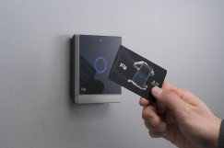However, the exploratory phase of installing and implementing such a particular system might be

time-consuming.

Card Technology is a process where data is transferred to the device from the card, followed by some validation on the input card done by the device to check if it's legit or not. Card technology facilitates so many things with just a button click through a device that supports this type of technology and provide easiness in many transactions. However, it might be annoying having to recharge the card, vulnerable to fluids so might be damaged easily.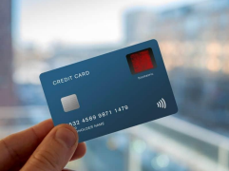

Voice Recognition is the study of a human speech by a computer for more than one purpose, usually for the goal of translating words and phrases or recognizing a certain voice. and translating it into electrical signals, which is then followed by a translation resulting in a code to have a meaning to this electrical signal. The code then attempts to comprehend the input and match it with the existing models before determining the appropriate answer to speak or just show the words on the screen.

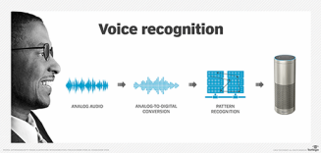

The speech recognition technology is supported by a wide range of

applications.eg: Google Translate.

An RFID Tag Circuit requires a microprocessor such as the STMicroelectronics ST25. However, be aware that the frequency of the application of almost all RFID systems run on one of two most used frequency bands 1-13.56 MHz or 2-125 KHz. There are two types of 13.56-megahertz bands: long range (LR) and short range (SR) (SR). Long-range objects have a frequency range of 13.6 to 13.7 megahertz, whereas short-range things have a frequency range of 13.6 to 13.7 megahertz.

**Problems**

When something becomes famous and is also implemented in public, attackers, and hackers take notice. AIDC technology has many flaws and weaknesses. In the case of Card Technology, data is sent across the air, but what if another individual intercepts this sensitive data? He will acquire access to all card information, allowing him to conduct unlawful activities. When it comes to QR The image of the code itself does not reveal what is within; it is simply a black and white label of that specific figure. As a result, a hacker might submit a fake QR code containing malware or other dangerous material, which people would scan and be hacked in seconds. AIDC technology should be able to meet these requirements. The information that was supplied before decoding should be securely secured, and QR codes should display what is inside and be scanned before entering what is within. When working with such technology, people should use extreme caution. Barcodes have several issues as well; packing items in factories may damage and break these barcodes, resulting in the inability to read the barcode. To be viewable, barcodes should be shown or printed in a calm area with no text or symbols around.

**Conclusion**

**References:**

● https://blog.beaconstac.com/2019/03/qr-code-examples-from-brands/ ● https://www.mhi.org/fundamentals/automatic-identification ● https://www.youtube.com/watch?v=pUom8hY8FXc

● http://www.autoidentification.my/

● https://en.wikipedia.org/wiki/QR_code

● https://code-cache.com/en/2021/09/30/what-is-a-qr-code-2/ ● https://www.fda.gov/radiation-emitting-products/electromagnetic-co mpatibility-emc/radio-frequency-identification-rfid

● https://www.embedded.com/a-data-driven-testing-methodology-for-r fid-systems/

● https://www.techtarget.com/searchcustomerexperience/definition/voi ce-recognition-speaker-recognition

● https://www.biometricupdate.com/201805/card-tech-and-fingerprint cards-to-work-together-on-biometric-cards-for-payments ●